**WS1050, Package parts 16 DUT Reliability**

**Test Procedures**

**Introduction:**

The purpose of this test procedure is for Hold Down and Cycling on package parts WS1050 from 16 DUT board, and this test procedure is using in WiSpry Lab in Irvine only.

**Hardware and Software requirement:**

1. Hardware:
2. Agilent 3631A, for VDD, +3.3V, -3.3V
3. Ke2000 for current measurement
4. Ke2400 for VSA test
5. PXI 1033 chassis
6. NI PXI-7813R, FPGA Card for RFFE and I2C
7. Software:

**Test program: WS1050, 16 DUT Reliability HD_Cycling Ver1.4**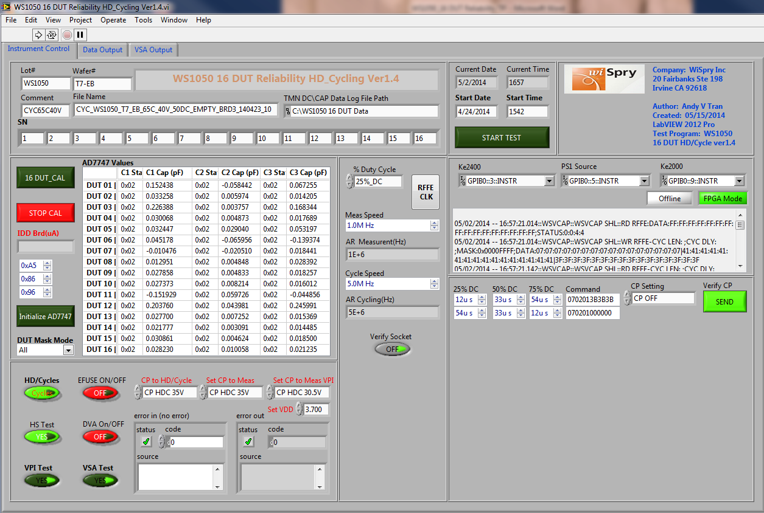

This test program will be found at the link below:

S:\Software_Control\Released\16 DUT Board\WS1050 16 DUT Reliability HD_Cycling Ver1.4

**Set up and run Test Program:**

1. Set temperatures from the oven/chamber:

Adjust temperatures from the oven/chamber to meet the requirement (25C, 45C, 55C, 65C or 85C with no control RH)

1. Verify Socket button should be “ON” when you run repeat measurement to verify socket stable 

**Note: look up table will be different when you run repeat measurement. The look up table file name is “Looping”**

1. Verify Socket button was set “OFF” by default to run HD/Cycling.
2. Open the test program at the link above. Click on  this button to run the test program. **Note: the test program will ask for a look up table, the look up table will be found on the desktop under 16 Sockets Read point folder, with the file name “16 socket cycling new”**
3. Sockets Calibration:

Make sure the conditions to run the test from oven/chamber meet the requirement then click on  button to zero out the 16 sockets, verify C1, C2 and C3 at window below are ~0 (zeroes).

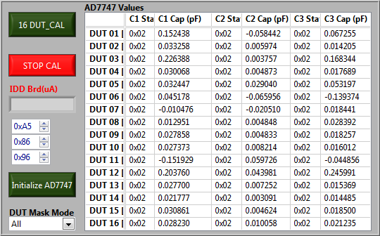

1. Click on  button to stop the calibration
2. Set the CP voltage to HD/Cycle by selecting CP voltage was setting on this box.
3. Set the CP voltage to measure capacitance by selecting CP voltage was setting on this box 
4. Set the CP voltage to measure VPI by selecting CP voltage setting on this box 
5. Verify VDD = 3.7V on this box 
6. Set percent duty cycle by selecting percent duty cycle was setting on this box

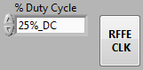

1. Enter Lot #, Wafer # into this box 
2. Enter serial number of 16 DUT



1. File name:



Cyc_Lot #_Wafer #_Design_Temperature_Voltage Cycle_Duty Cycle_Board_Date_Run #

1. Directory to save the test data: this is by default



1. Set the number of cycles to complete: Enter the number of cycles you want to run into these boxes.  

**Note: These two numbers should be the same for cycling, and not the same for HD.**

1. You have an option to start the test immediately by clicking on start test button or you can select date/time to start running the test program.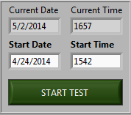
2. You have an option to run HD/Cycle with E-Fuse ON/OFF by clicking on this button 
3. You have an option to run HD/Cycle with DVA ON/OFF by clicking on this button 
4. You also have an option to measure VPI, VSA by selecting Yes/No on these two buttons, these two buttons were set “Yes” by default.
5. This button was set by default “Cycles” 
6. Handshake check was set “YES” by default 
7. Load parts into 16 sockets and verify Cmin at the window below. Cmin is ~1.2pF for all 3 banks, C1, C2 and C3.

